Concept Map: Carlos Garaicoa “Ideas of Utopian Societies”

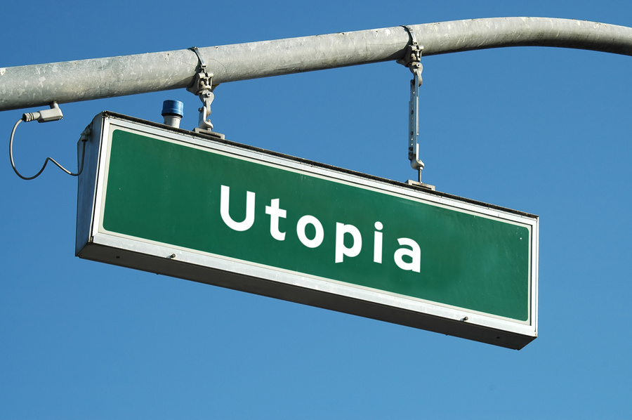
(Source: http://fr.fotolia.com/id/195032)
What is a “utopia”?

Summary/Explanation

If you could draw your own picture of paradise, what
would it look like? Try to be as descriptive as possible.

From the reading, explain why Carlos Garaicoa
chooses to use architecture from Havana and
other cities around the world in his artwork. Also, from
reading, how does this relate to the theme of
“utopia”?
(Website: http://www.tate.org.uk/research/tateresearch/
majorprojects/garaicoa/work_1.htm)

Analyze Garaicoa’s work, Letter to the Censors. Click on
the various links of this work. What do you think his
message is in this piece? Explain.
(Website: http://www.tate.org.uk/research/tateresearch/
majorprojects/garaicoa/work_6.htm)

