Study Guide:
My Pie Town, by Debbie Grossman

The exhibition Enhanced! features a selection of six images from the suite My Pie Town, by artist Debbie Grossman. “My Pie Town reworks and re-imagines a body of images originally photographed by Russell Lee for the United States Farm Security Administration in 1940. Using Photoshop to modify Lee’s pictures, I have created an imaginary, parallel world - a Pie Town populated exclusively by women.” http://www.debbiegrossman.com/index.php?/projects/my-pie-town/

This study guide is prepared by the USFCAM and contains the following information:

• Biography of Debbie Grossman
• My Pie Town, artist statement by Debbie Grossman
• Biography of Russell Lee
• Original Pie Town images by Russell Lee, corresponding to the Grossman images in Enhanced!, retrieved from The Library of Congress

Biography of Debbie Grossman
Debbie Grossman is interested in playing with time, re-imagining history, and reviving archival images and documents. She received an MFA in Photography, Video, and Related Media from the School of Visual Arts, where she won the Paula Rhodes Memorial Prize, and holds a BA in Women’s Studies and Art History from Barnard College. She is also a Senior Editor at Popular Photography Magazine, where she is the resident expert on image editing software and technique. Her work is in the collection of the Metropolitan Museum of Art and the Jewish Museum, among others. She is represented by the Julie Saul Gallery, New York.
Contact: info [at] debbiegrossman.com

My Pie Town, artist statement by Debbie Grossman

In the spring of 1940, Russell Lee wrote to his boss at the Farm Security Administration, Roy Stryker, proposing to spend several weeks shooting Pie Town, New Mexico, a small settlement of homesteaders near the western edge of the state. Lee wanted to photograph there because he felt Pie Town represented a kind of hardy, small town community that was disappearing in America. His pictures of the town are tinged with his mythologizing of a difficult way of life and the land-conquering kind of patriotism that's a foundation of the American story. I share Lee's nostalgia. Seventy years later, I am drawn to a similar utopian ideal. I'm filled with a longing to connect with that time and the people in Lee’s images – I've had a lifelong obsession with frontier life. I fantasize about locating myself within those pictures and that time. So in an attempt to make the history I wish was real, I have made over Pie Town to mirror my fantasy.
In this work, I take a selection of Lee's beautifully-photographed body of images and re-imagine, revise, and reconstruct them using Photoshop. The archive I have created resembles Lee's with an important difference – in My Pie Town, the rag-tag community of homesteaders is populated exclusively by women.
In some of my revisions, I have taken male bodies and rendered them to look like masculine women; in others, I have taken pairs of women, shifted their distance and body language, and brought them closer to create a sense of intimacy. In some of the pictures I have created women so masculine, or so ambiguously gendered, that they may not, for some viewers, clearly read as one gender or the other. I’ve also left a few images untouched, allowing for another dimension of re-reading Lee's work.
Though the Pie Town pictures were never widely published as a group, the images have a sort of a cult following. Posted by the Library of Congress on the photo-sharing website Flickr, they attract endless notes and commentary. Paul Hendrickson wrote an article in 2005 for Smithsonian Magazine about returning to Pie Town; David Margolick wrote a similar piece in the New York Times in 1994. And in 2001, Joan Myers wrote a fascinating biography of Doris Caudill, called Pie Town Woman. I believe that part of what makes the pictures so seductive for contemporary viewers is their extreme level of detail. Lee was a very careful chronicler of the details of everyday life. There's also a casualness and an immediacy to Lee's style.
My/Lee's pictures also have the appeal as a body of work that slipped through history's cracks. Because they work so much better as a group or a picture story, and perhaps also because they were made at the tail end of the Depression, Lee's Pie Town images never become iconic symbols of the Depression itself the way that, say, certain images by Walker Evans or Dorothea Lange did. I, like Joan Myers, find Lee's Pie Town pictures particularly compelling because they seem so respectful of his female subjects. Of course, gender roles in Lee’s original pictures are fairly traditionally divided, and any hint of sexuality is sublimated, but I could not have made my female version of Pie Town if there hadn't been space and flexibility for my re-reading in Lee's nuanced photographs.
Because the images of Lee's time in Pie Town are available in high resolution form from the Library of Congress, I was able to get close to Lee's images on a pixel level. For me, working with photographs and editing them so closely in Photoshop is a kind of an intimate act. Zooming in and carving a feminine jaw out of a masculine one, or manipulating the touch of one woman's hand on another's shoulder is a way for me to access and merge my desire with figures which would have otherwise remained frozen in time. I've begun to think of Photoshop itself as my medium – I'm fascinated by the fact that it shares qualities with both photography and drawing. This work creates something that reads as a photograph, and is infinitely reproducible like a photograph, but at the same time depends heavily upon the intervention of my hand.

Particularly because my work takes as its starting point a body of images that is Americana, that was made to be a political tool to encourage pride in this country and its homesteading, agrarian roots, I enjoy imagining My Pie Town working as its own kind of (lighthearted) propaganda.

http://www.debbiegrossman.com/index.php?/projects/more-about-pie-town/

Biography of Russell Lee

In 1927 Russell Lee (1903-1992) married painter Doris Emrick and soon began painting. Shortly thereafter the two moved to a small artist's community in Woodstock, NY. Over the next few years Russell Lee struggled with painting and in 1935 he bought a camera to try to help him visually. He fell in love with photography.

During his stay in Woodstock, Russell Lee began taking photographs that reflected his concerns for the struggling working class. In 1936 he became interested in a group of photographers in Washington D.C. that were doing socially documentary work. As a result, Russell Lee met with Roy Stryker, the director of the photography project for the Farm Security Administration (FSA). Stryker hired Lee as well as Walker Evans, Dorthea Lange, Arthur Rothstein, and others to create a body of propaganda photographs to document the success of federal rural relief projects. Soon Russell Lee was photographing throughout the Midwest for the FSA documenting the plight of farmers through the Great Depression and droughts of the 1930s. In the midst of all of his traveling, Russell Lee's marriage to Doris ended and in 1938 he met and married newspaper reporter Jean Smith. They began working together, Russell Lee taking the photographs and Jean writing short essays about the images. By 1940 Russell Lee was known as one of the best photographers working for the FSA.

During the next several years Russell Lee, like many FSA photographers, helped the government with the war effort by taking photographs for the Air Transport Command. When the war ended Russell Lee took a short break and then did some more work for the government photographing the conditions of the coal miners in the Rocky Mountains and Appalachia. Between 200 and 300 of Russell Lee's images were used in the fight to clean up the coal industry. In 1947 Roy Stryker contacted Russell Lee about taking some industrial photographs for a project he was developing for Standard Oil of New Jersey. Russell Lee's images concentrated on how oil and it's products related to peoples everyday lives. Over the next several years Russell Lee focused on industrial photography. In 1965 he began teaching at the University of Texas and this remained one of his passions until he retired in 1973.

Read more about Russell Lee Biography by www.leegallery.com

Original Russell Lee photographs, retrieved from the Library of Congress Prints and Photographs Division (retrieval information following images)

Main Street, Pie Town, New Mexico (October, 1940)

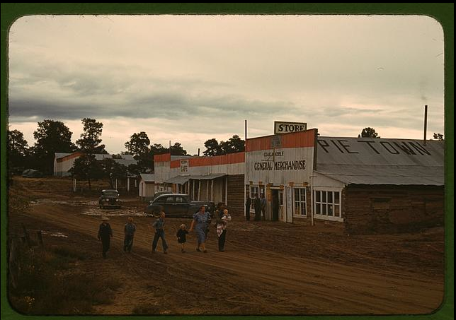
Faro and Doris Caudill, homesteaders, Pie Town, New Mexico (October, 1940)

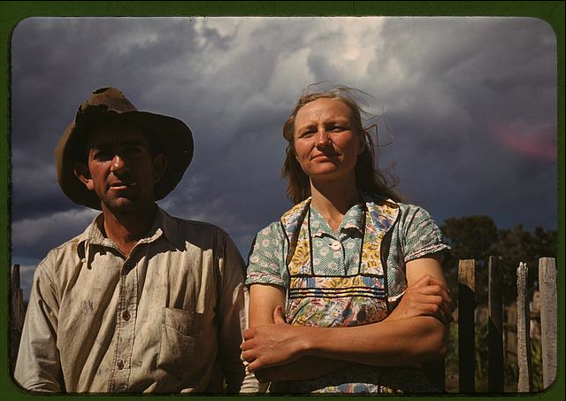
The Faro Caudill [family] eating dinner in their dugout, Pie Town, New Mexico (October, 1940)

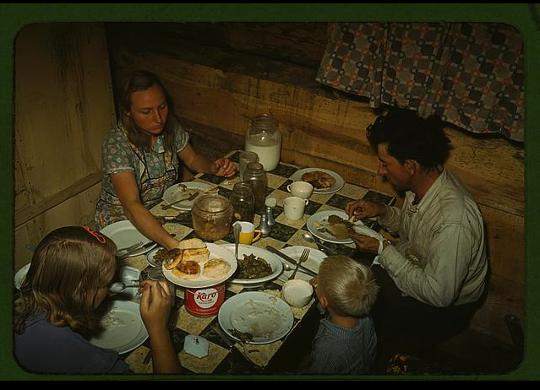

Jack Whinery, homesteader, with his wife and the youngest of his five children, Pie Town, New Mexico (September, 1940)

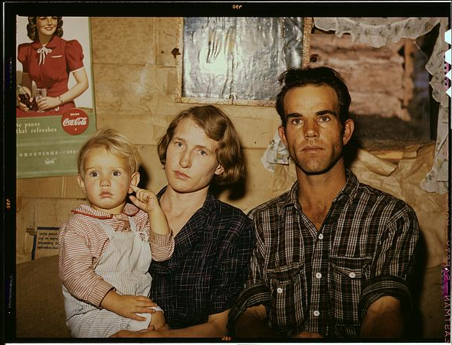
Tying a ribbon on a calf's tail was one of the feature attractions at the Pie Town, New Mexico Fair rodeo (October, 1940)

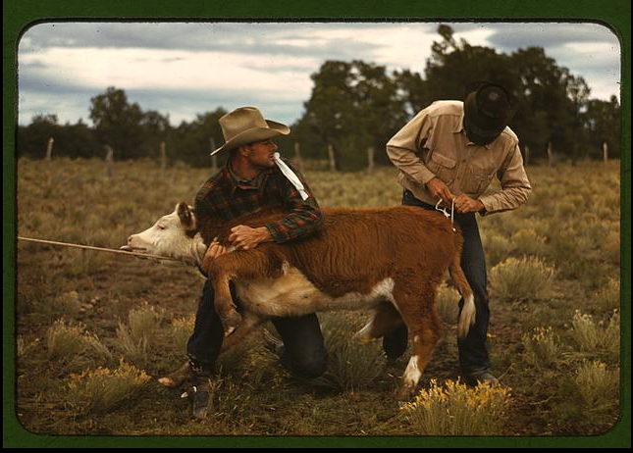

George Hutton, Jr., standing by mounted animals which he killed. Pie Town, New Mexico (June, 1940)

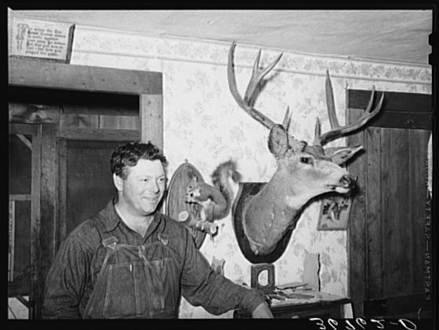
Main Street, Pie Town, New Mexico
- Digital ID: (digital file from original slide) fsac 1a34148 http://hdl.loc.gov/loc.pnp/fsac.1a34148
- Reproduction Number: LC-DIG-fsac-1a34148 (digital file from original slide) LC-USF351-357 (color film copy slide)
Repository: Library of Congress Prints and Photographs Division Washington, D.C. 20540 USA http://hdl.loc.gov/loc.pnp/pp.print
Faro and Doris Caudill, homesteaders, Pie Town, New Mexico
- Digital ID: (digital file from original slide) fsac 1a34096 http://hdl.loc.gov/loc.pnp/fsac.1a34096
- Reproduction Number: LC-DIG-fsac-1a34096 (digital file from original slide) LC-USF351-317 (color film copy slide)
Repository: Library of Congress Prints and Photographs Division Washington, D.C. 20540 USA http://hdl.loc.gov/loc.pnp/pp.print
The Faro Caudill [family] eating dinner in their dugout, Pie Town, New Mexico
- Digital ID: (digital file from original slide) fsac 1a34105 http://hdl.loc.gov/loc.pnp/fsac.1a34105
- Reproduction Number: LC-DIG-fsac-1a34105 (digital file from original slide) LC-USF351-326 (color film copy slide)
Repository: Library of Congress Prints and Photographs Division Washington, D.C. 20540 USA http://hdl.loc.gov/loc.pnp/pp.print
Jack Whinery, homesteader, with his wife and the youngest of his five children, Pie Town, New Mexico
Digital ID: (digital file from original transparency) fsac 1a34170 http://hdl.loc.gov/loc.pnp/fsac.1a34170
- Reproduction Number: LC-DIG-fsac-1a34170 (digital file from original transparency) LC-USF351-586 (color film copy slide)
Repository: Library of Congress Prints and Photographs Division Washington, D.C. 20540 USA http://hdl.loc.gov/loc.pnp/pp.print
Tying a ribbon on a calf's tail was one of the feature attractions at the Pie Town, New Mexico Fair rodeo
- Digital ID: (digital file from original slide) fsac 1a34157 http://hdl.loc.gov/loc.pnp/fsac.1a34157
- Reproduction Number: LC-DIG-fsac-1a34157 (digital file from original slide) LC-USF351-378 (color film copy slide)
Repository: Library of Congress Prints and Photographs Division Washington, D.C. 20540 USA http://hdl.loc.gov/loc.pnp/pp.print
George Hutton, Jr., standing by mounted animals which he killed. Pie Town, New Mexico
- Digital ID: (intermediary roll film) fsa 8b25358 http://hdl.loc.gov/loc.pnp/fsa.8b25358
- Reproduction Number: LC-USF34-036762-D (b&w film neg.)
Repository: Library of Congress Prints & Photographs Division Washington, DC 20540 http://hdl.loc.gov/loc.pnp/pp.print

