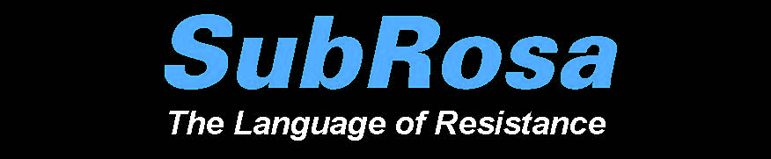

Title
Applying What You’ve Learned about Khaled Jarrar: Designing a Stamp

Concept/Main Idea of Lesson
The purpose of this lesson is to allow students the opportunity to design a stamp that reflects techniques and approaches featured in the art show SubRosa, with special emphasis on the work of Palestinian artist Khaled Jarrar.

Intended Grade Levels
Grades 9-12

Infusion/Subject Areas
Visual Art
Social Studies

Curriculum Standards
Visual Art:
VA.68.S.2.3: Use visual-thinking and problem-solving skills in a sketchbook or journal to identify, practice, develop ideas, and resolve challenges in the creative process.
VA.68.S.2.1: Organize the structural elements of art to achieve artistic goals when producing personal works of art.
VA.68.O.1.3: Combine creative and technical knowledge to produce visually strong works of art.
VA.68.O.1.4: Create artworks that demonstrate skilled use of media to convey personal vision.
VA.912.S.2.6: Incorporate skills, concepts, and media to create images from ideation to resolution.

Social Studies:
S.912.H.1.2: Describe how historical events, social context, and culture impact forms, techniques, and purposes of works in the arts, including the relationship between a government and its citizens.
SS.912.H.1.5: Examine artistic response to social issues and new ideas in various cultures.
SS.912.H.2.1: Identify specific characteristics of works within various art forms (architecture, dance, film, literature, music, theatre, and visual arts).
SS.912.H.2.3: Apply various types of critical analysis (contextual, formal, and intuitive criticism) to works in the arts, including the types and use of symbolism within art forms and their philosophical implications.
SS.912.H.2.4: Examine the effects that works in the arts have on groups, individuals, and cultures.
SS.912.H.2.5: Describe how historical, social, cultural, and physical settings influence an audience's aesthetic response.

Instructional Objectives
Students will:
- draw a mental map of a place;
- conceptualize and design a stamp based on the concept of “place”;
- apply techniques and approaches used in the art show SubRosa (with special emphasis on the work on the work of Palestinian artist Khaled Jarrar) to design and create an original piece of art;
- share their work with others;
- provide feedback to peers on their creations.

Learning Activities Sequence
Set Induction/Hook: Mental Cartography Exercise: Place

Say: Close your eyes and envision a place that is important to you. Make a mental note of unique or special features. Open your eyes and draw that place, includinge as many details as you can. (5 minutes). (This place could be your room, your home, your school, your city, your state, your country, etc.).

Class Discussion: Ask students to recall the work of Khaled Jarrar and how the concept of “place” is manifested.

Say: Today you will have the opportunity to design your own stamp to reflect the concept of “place.”

Design Project: Designing a Stamp: Place

Say: Select a place of importance to you. It could be the place that you drew in your sketch or another place. Recall that Jarrar used the Palestinian sunbird on his stamps. Think of one central image/symbol to represent the place that you chose. Create a drawing with your image/symbol as the central focus (using colored pencils or collage elements, if desired). Utilize additional text and imagery to complete your composition.

Distribute Art Project Evaluation Rubric and explain each of the four components that will be assessed.

Evaluation
Art Project Evaluation Rubric

Optional Extension Activities
Allow students to share their work with their classmates by either displaying in the classroom or projecting via a document camera. Allow opportunities for student-led questions and answers.

Materials and Resources
Handout: Art Project Evaluation Rubric
Drawing Paper
Colored Pencils

Optional (Collage): Old Magazines, Glue, Scissors

