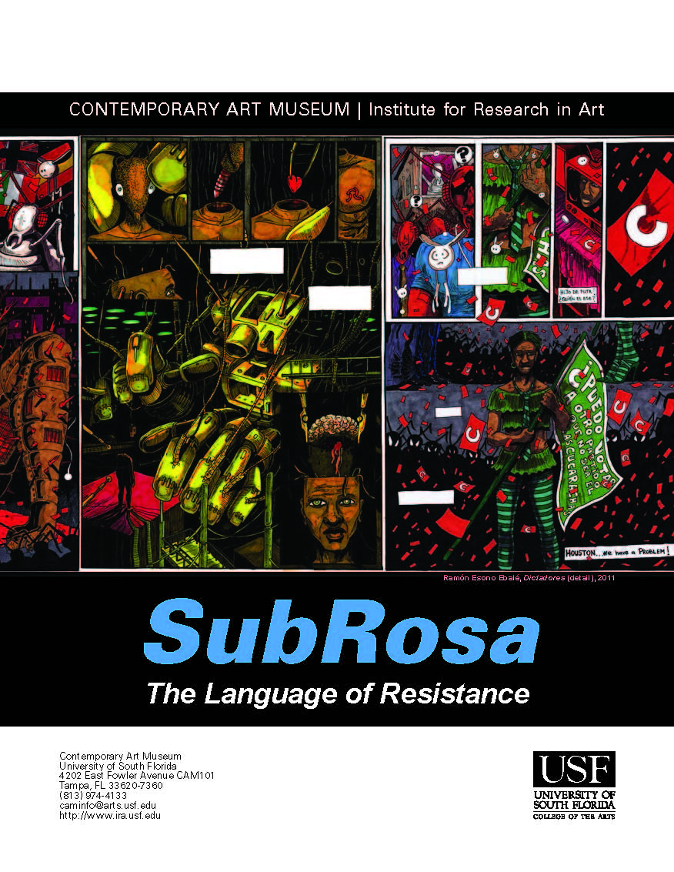

Title
Zanele Muholi: A Closer Look

Concept/Main Idea of Lesson
In this lesson, students will engage in a closer examination of the work by South African artist Zanele Muholi’s work, noting important influences on the artist.

NOTE: Because some of Muholi’s work has adult material, preview all web sites and resources used to determine appropriateness for your students.

Intended Grade Levels
Grades 9-12

Infusion/Subject Areas
Visual Arts
Social Studies

Curriculum Standards
Visual Arts:
VA.5.C.3.3: Critique works of art to understand the content and make connections with other content areas.
VA.5.H.1.1: Examine historical and cultural influences that inspire artists and their work.
VA.68.C.3.1: Incorporate accurate art vocabulary during the analysis process to describe the structural elements of art and organizational principles of design.
VA.912.H.3.1: Synthesize knowledge and skills learned from non-art content areas to support the processes of creation, interpretation, and analysis.
Social Studies:
S.912.H.1.2: Describe how historical events, social context, and culture impact forms, techniques, and purposes of works in the arts, including the relationship between a government and its citizens.
SS.912.H.1.5: Examine artistic response to social issues and new ideas in various cultures.
SS.912.H.2.1: Identify specific characteristics of works within various art forms (architecture, dance, film, literature, music, theatre, and visual arts).
SS.912.H.2.3: Apply various types of critical analysis (contextual, formal, and intuitive criticism) to works in the arts, including the types and use of symbolism within art forms and their philosophical implications.
SS.912.H.2.4: Examine the effects that works in the arts have on groups, individuals, and cultures.
SS.912.H.2.5: Describe how historical, social, cultural, and physical settings influence an audience's aesthetic response.

Instructional Objectives
The student will:
- examine selected works by South African artist Zanele Muholi;
- become familiar with the genre of photographic portraiture;
- identify artistic influences that have had an impact in the artist’s work;
- make connections between the artist’s personal and cultural experiences and her work;
- consider how the artist used photography as a platform for protest and dissidence;
- listen to a contemporary song related to gay rights.

Learning Activities Sequence
Set Induction/Hook: Write the word “portrait” on the board. Ask students to explain in their own words what the term means. Ask:
- What can portraits show about a person?
- How can a painter or photographer determine what is revealed about the subject in portraits?
Tell students that as they view and consider the artwork of Zanele Muholi today, they should think about the artist’s use of portraiture, setting, and composition.

Teacher Presentation, Questioning, & Class Discussion: Using the presentation entitled, Zanele Muholi -- Art Analysis, present the students with images of selected works by Muholi. Teacher Background Notes are provided in the “Notes View;” review those before you share the presentation with students.

As you make the presentation, prompt and probe students by asking questions related to the artists’ work such as:

- Faces and Phases (2006-ongoing): What do these portraits tell us about the people who are photographed? What do these portraits tell us about the photographer? Why are these works important? How can portraiture be used to promote activism?
- How can you compare and contrast Seydou Keïta’s work and Muholi’s Faces and Phases series (2006-ongoing)?
- How can you compare/contrast Stereo Styles (1988) by Lorna Simpson to Muholi’s Faces and Phases (2006-ongoing) series?
- Being (2007): What do these portraits tell us about the people who are photographed? What do these portraits tell us about the photographer? Why are these works important?
- What are some similarities and differences between photography that is “staged” or “posed” and photography that is more journalistic? Is one form of photography more “true” or “real” than the other? Why or why not?
- Queercide (2008-ongoing): How can photography be used in a socially activist way? This work is much more documentary-based and journalistic than some of Muholi’s other work. Does that make it more effective? Why or why not? Which of Muholi’s works is most effective in reaching her goal of being a “visual activist”?

Closure:
Play the song, “Same Love” by Macklemore (2012). To enhance comprehension, download and print the lyrics, distributing to students so they can follow along. [
Note: the “official version” of the music video can be easily found on youtube.com.]

Evaluation
Monitor student comprehension throughout the presentation by the responses given to the questions posed.

Optional Extension Activities
See Teaching Tolerance’s excellent series, Art and Activism (http://www.tolerance.org/lesson/art-and-activism?elq=365839b120964ec59c55b85f69062e1b&elqCampaignId=87) for additional activities related to photography and social activism.

Materials and Resources
Presentation: Zanele Muholi -- Art Analysis
Computer, Projector, and screen
Audio Speakers for “Same Love”

References
Lorna Simpson Studio (n.d.). Lorna Simpson [Web Page]. Retrieved from http://lsimpsonstudio.com/

Macklemore. (2012). Same Love, The Heist. NY: Macklemore LLC.

Muholi, Z. (n.d.). Zanele Muholi [Web Page] Retrieved from http://www.zanelemuholi.com/

Robert Mapplethorpe Foundation (n.d.). Robert Mapplethorpe [Web Page]. Retrieved from http://www.mapplethorpe.org

Seydou Keïta Photographer (n.d.). Seydou Keïta Photographer [Web Page]. Retrieved from http://www.seydoukeitaphotographer.com/#13

Stevenson Gallery (n.d.). Zanele Muholi [Web Page]. Retrieved from http://www.stevenson.info/artists/muholi.html

Südafrika: Land der Kontraste: The German Gateway to South Africa. (2010, May 31). Exklusive interview with Zanele Muholi [Blog Post]. Retrieved from http://2010sdafrika.wordpress.com/2010/05/31/exklusive-interview-with-zanele-muholi/

Teaching Tolerance. (2013). Art and Social Justice: What is a Portrait? Retrieved from http://www.tolerance.org/lesson/art-and-social-justice-what-portrait?elq=365839b120964ec59c55b85f69062e1b&elqCampaignId=87

Weems, C. M. (n.d.). Carrie Mae Weems [Web Page]. Retrieved from http://carriemaeweems.net

